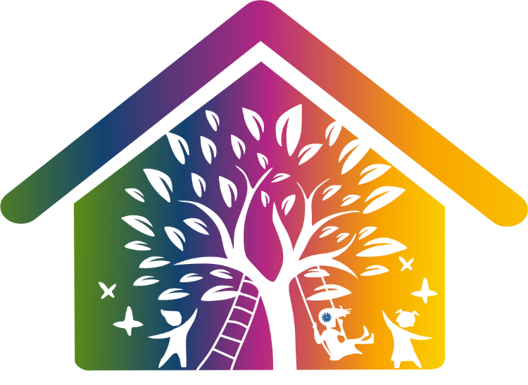

Family First Care
Apricot House

GOOD NEIGHBOURHOOD POLICY

Review Date 1st November 2025
Next Review date: 1st November 2026

Policy Purpose and Legal Framework
This policy sets out how Family First Care ensures respectful, responsible, and proactive relationships with neighbours and the wider community. We recognise that community confidence is essential to the success of our children's homes. This policy aligns with:
- Children’s Homes (England) Regulations 2015 (Regs 5, 6, 11, 12, 13)
- Working Together to Safeguard Children (2023)
- Ofsted SCCIF
- Equality Act 2010
- Human Rights Act 1998

Policy
The purpose of this policy is to give counsel to the neighbours of Family First Care children’s homes. The policy is likewise, a reminder to the staff and inhabitants of the children’s homes about their obligations to the local community as well as their responsibilities to the childcare task. The policy is envisioned to help and guide and has been delivered by the hard work of neighbours and staff from the residential home. We recognise that a document such as this can only support and is certainly not a substitute for the formation of good relationships between a home and its neighbours.

Introduction
Local Authorities have a duty to ‘look after’ children who are identified as being ‘in need’ for a variety of reasons. The level of care for children that are ‘looked after’ should be of the highest standard with the aim of returning them to their families, if it is practical, feasible and safe to do so. In following this obligation, we will ensure that children ‘looked after’ are given the opportunity to reach their maximum potential in respect of education, health, and social achievement. All aspect of this service is governed by the Children Act 1989 and 2004, Quality Standards and Children’s Homes Regulations that guide the way staff look after children.
The objective of the children’s home would be to ensure the ‘looked after’ children and young people who dwell in the homes are viewed as a feature of the local community as opposed to isolate from it. Opportunities, choices, and access to facilities should be presented and enjoyed by both residents and staff; the same as any other residents, but should also try to make a positive contribution to the local community.
Family First Care is dedicated to ensuring that whilst children and young people are in our care, as well as safeguarding their welfare, we will do all in our power to inspire and teach them how to be mindful individuals of the community.
This illustrates a crucial point: all members of local communities, including employees and residents of children's homes, have rights that are matched by obligations to others. Particularly, the adults in charge of the children’s upbringing must behave like good parents and provide a virtuous example for them. Our goal is to advance the wellbeing and safety of the children entrusted to our care, and in order to do so, we value the feedback and support of our local neighbours.
Above all, it is crucial that staff members pay attention to neighbours' worries and address them in a way that reflects their own sense of neighbourliness. This should be done as a component of the childcare duty, not in a way that undermines the staff's obligation to perform their childcare duty.
In managing the home, Family First Care and its staff are committed to the following standards.
We will:
Create a positive connection with the local community
Family First Care actively supports children and young people to engage in community life in a way that fosters mutual respect, confidence, and opportunity. Participation in events, volunteering, or use of public services (like libraries, gyms, parks) will be encouraged and risk-assessed in line with individual care plans.
- Staff will be expected to help the children ‘looked after’ accept and respect the rights of others and in particular the immediate neighbours and local community.
Staff should:
- Know the local community
- Obtain information on local facilities.
- Present good images in the local community.
- Have good and appropriate communication systems, such as greetings cards, point of contact and follow-up process.

Be mindful of how the building will affect the neighbourhood
The look of the building needs to reflect a positive cared for image.
Staff will:
- Be mindful of how the building and grounds look, keep rubbish under control.
- Maintain good boundaries and fences.
- Keep noise to a minimum (e.g., double glazing, controlling stereos, T.V. and computer games and advising visitors to the home).
- Keep gardens maintained.
- Draw curtains as appropriate.
- Put lights on or off as appropriate.
- Ensure visible supervision of children’s activities.
- Ensure appropriate parking.

Manage how staff and members of Family First Care present themselves
It is vital that staff and others accept the importance of their role in relation to the children’s home and the community within which it is situated.
Staff will:
- Present as good role models for the children and young people.
- Be ambassadors for the home, during working times and outside working times.
- Be accountable for the children’s behaviour outside the home in the grounds, in the locality and in community facilities.
- Be mindful of combinations and numbers of young people going out separately or together.
- Use and support local facilities.
- Respond to complaints appropriately.
- Act as competent parents; being consistent & offering appropriate structures & boundaries.
- Help young people accept and respect themselves and others.
Staff will promote equality, diversity, and inclusion by modelling respect for people of all backgrounds, beliefs, and lifestyles in the local community. Any discriminatory behaviour toward or by a neighbour must be reported and investigated.

Where a neighbour’s concern relates to behaviour that may also raise safeguarding issues or serious incidents (e.g. criminal damage, exploitation concerns), staff must escalate the concern to the Designated Safeguarding Lead (DSL) in line with the Safeguarding & Child Protection Policy. Behaviour Management and Positive Relationships Policies also apply.

Care for the appearance of the children
To assist with their feeling of self-worth, children and young people should:
- Wear good clothing and where appropriate school uniform.
- Appear well cared for and wear clothes suited to the weather conditions.
- Present acceptable behaviour.
- Accept that they are accountable for their behaviour outside the home.

React quickly and appropriately when incidents occur
To respond quickly to concerns and complaints, accepting that each situation is unique.
Staff will:
- Receive training to deal effectively with incidents as part of a core programme of training.
- Receive clear guidance to enable them to respond effectively.
- Identify a person who will take responsibility and co-ordinate action.
- Respond as immediately as possible thereby preventing an issue becoming bigger.
- Advise the manager who will respond personally or follow up on actions.
- Ensure more senior managers are made aware.
- Inform the community and or individual of action taken as appropriate.
- Advise neighbours of the use of the complaint’s procedure where appropriate.
- Check if satisfied with the outcome/action taken.

Address on-going practices
Maintaining good relations with the community is a never-ending process. Staff and managers should:
- Keep practices in relation to public relations on staff meeting and supervision agendas.
- Keep in touch with local neighbours.
- Check on their views and well-being.
- Keep them informed of developments that may affect them.
- Be a good neighbour.
- Consider becoming involved in neighbourhood watch schemes etc.
- Assist in times of crises.
- Encourage liaison groups.
- Be aware of local community issues.
- Involve staff, children and young people in local community events and resources

Address training issues
To improve staff confidence and attitudes when tackling the issues presented to them. Managers will provide training which:
- Deals with incidents/complaints.
- Enables positive working with the local community.
- Tackles behaviour management in relation to the local community.
- Promotes the role of the corporate parent.

Maintaining community relationships following an incident
The following is staff guidance to enable staff to deal effectively with matters which may affect the local community. The most senior person on duty will be responsible for ensuring that the following guidance is implemented
If a serious incident results in negative media attention or reputational risk, Family First Care will develop a coordinated response with senior leadership and, where necessary, notify Ofsted under Regulation 40. A clear communication plan may include written updates to neighbours or public meetings in partnership with local authorities.

Incident
- Immediately assess the situation (depending on the seriousness it may be necessary to contact a manager).
- Consider any aspects that may cause adverse reactions from the community.
- Take details to assist with the matter being dealt with effectively.
- Inform those involved of the complaint procedure.

Identify person to coordinate - (within 30 minutes)
- Take positive action.
- Liaise with neighbours.
- Demonstrate that you are in control.
- Take a balanced approach, avoid taking an aggressive or defensive stance.
- Manage your own feelings.

Inform of action taken (as soon as appropriate, but by end of shift)
- If a young person has been abusive or caused damage - be proactive.
- Inform neighbour of sanction to be imposed or get young person to apologise / make amends (put yourself in their place, how would you feel?).
Inform manager at earliest opportunity
- Depending on the seriousness it may be necessary to contact them in their ‘off’ time.

Manager to follow up (within 7 days)
- The manager or senior member of staff should visit in person to ensure the neighbour is satisfied with the way that the situation was handled.
- This should be followed up again at a point in the future.
- Remind those involved of the complaint’s procedure.

Advise senior managers
- If the nature of the incident is particularly serious; ensure that senior managers are briefed at the earliest opportunity.
- Neighbours are entitled to contact senior management directly.
Complaints and representations
- Where a neighbour is unhappy with the response/outcome, they should again be advised of the complaint’s procedure.
- In addition, they should be informed of how to access senior management

Monitoring and Review
This policy will be reviewed annually, and feedback from neighbours, staff, and young people will inform any updates. Community concerns, complaints, and engagement will be reviewed quarterly at management meetings. Learning from incidents will inform staff training and reflective practice.

Related Policies:
- Behaviour Support and Positive Relationships Policy
- Safeguarding and Child Protection Policy
- Staff Code of Conduct
- Complaints Policy
- Incident Reporting and Regulation 40 Notifications Policy

